

**Khwaja Yunus Ali University**

***LAB Report***

**Name of the Department: Computer Science and Engineering**

**Course Code: CSE 0713-1104**

**Course Title: Electrical Circuit Lab**

**Report No.: 05**

**Topic: Verification of Nodal analysis using digital simulation.**

**Date of the Experiment: 16-03-2025**

**Submission Date: 13-04-2025**

**Instructor Signature & Date**

|  |  |  |  |  |
| --- | --- | --- | --- | --- |
| **Submitted by –** | |  | **Submitted to –** | |
|  | **Name: Md. Sabbir Hossain Rahat**  ID Number: 06224205101017  Batch No: 18th  Semester: 1st Year 2nd Semester  Khwaja Yunus Ali University |  |  | **Name: Sakil Ahammed**  Lecturer  Department of EEE  Khwaja Yunus Ali University |

**Name of the Experiment:**

Verification of Nodal Analysis Using Hardware and Digital Simulation

**Objectives**

To verify Nodal Analysis using hardware and digital simulation.

**Theory:**

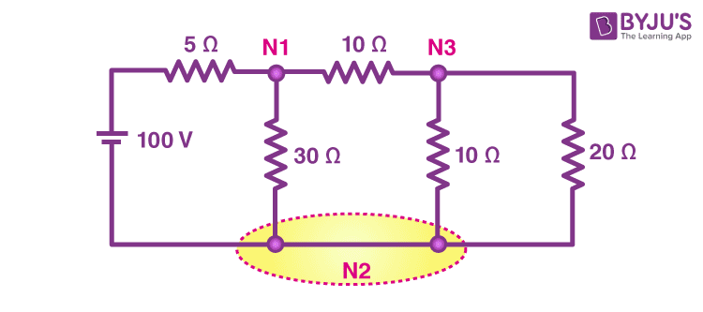Nodal Analysis is a fundamental technique in circuit analysis that calculates voltages at various nodes by applying Kirchhoff’s Current Law (KCL). By focusing on node voltages rather than branch currents, this method streamlines complex circuit problems into a more efficient and systematic solution.

Fig: Electrical Circuit for Node Voltage Calculation

**General Nodal Analysis Formula:**

$$∑\frac{V_{x}-V_{adjacent}}{R_{connected}}=0$$

For any node *Vx*​ connected to resistors and voltage sources:

* $V_{adjacent}$: Voltage at neighboring nodes.
* $R_{connected}$**​**: Resistors linked to the node.

**Circuit Diagram:**

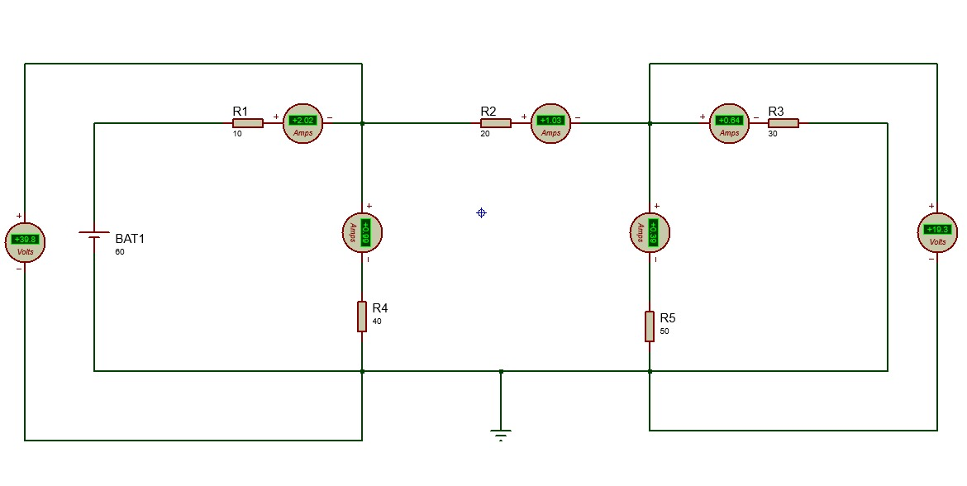

Fig: Circuit diagram nodal analysis

**List of Apparatus:**

A working computer.

Software: Proteus 8 professional.

Tools: 1. Resistor, 2. Cell, 3. Grounding, 4. Wires, 5. DC Ammeter, 6. DC Voltmeter

**Working Procedure:**

1. We constructed the circuit as per the diagram in Proteus 8 Professional.
2. We identified the principal nodes and selected a reference (ground) node.
3. We applied Kirchhoff’s Current Law (KCL) to each non-reference node.
4. We solved the equations to determine node voltages.
5. We measured the voltage at each node using simulation.
6. We compared the theoretical and simulated values.

**Calculations:**

Given Values:

* Voltage Source (V): 60v
* Resistor: $R_{1}=10Ω,R_{2}=20Ω,R_{3}=30Ω,R_{4}=40Ω,R_{5}=50Ω$

**At Node $1\left(V_{1}\right)$**  :

$$\frac{V_{1}-V_{s}}{R_{1}}+\frac{V_{1}}{R_{4}}+\frac{V_{1}-V_{2}}{R_{2}}=0$$

Substituting values:

$$\frac{V_{1}-60}{10}+\frac{V_{1}}{40}+\frac{V_{1}-V_{2}}{20}=0$$

Multiply by 40 (LCM):

$$4\left(V_{1}-60\right)+V_{1}+2\left(V_{1}-V_{2}\right)=0⟹7V_{1}-2V_{2}=240 (\text{ Equation }1)$$

**At Node $2\left(V_{2}\right)$:**

$$\frac{V_{2}-V_{1}}{R_{2}}+\frac{V_{2}}{R_{3}}+\frac{V_{2}}{R_{5}}=0$$

Substituting values:

$$\frac{V_{2}-V_{1}}{20}+\frac{V_{2}}{30}+\frac{V_{2}}{50}=0$$

Multiply by 30 (LCM):

$$15\left(V_{2}-V_{1}\right)+10V_{2}+6V_{2}=0⟹-15V_{1}+31V_{2}=0 (\text{ Equation }2)$$

Solving Equations:

From Equation 2:

$$V_{1}=\frac{31}{15}V_{2}$$

Substitute $V_{1}$ into Equation 1:

$$7\left(\frac{31}{15}V_{2}\right)-2V_{2}=240⟹\frac{217V_{2}}{15}-2V_{2}=240⟹\frac{187V_{2}}{15}=240$$

$$\begin{matrix} & V_{2}=\frac{240×15}{187}≈19.25 V \\ & V_{1}=\frac{31}{15}×19.25≈39.8 V\end{matrix}$$

**Observation Table:**

| **SL No** | **Input Voltage (V)** | **V1 (Simulated)** | **V2 (Simulated)** | **V1 (Calculated)** | **V2 (Calculated)** |
| --- | --- | --- | --- | --- | --- |
| 1 | 60 | 39.8 | 19.3 | 39.8 | 19.25 |
| 2 | 70 | 46.4 | 22.5 | 46.35 | 22.4 |
| 3 | 30 | 19.9 | 9.63 | 19.9 | 9.60 |
| 4 | 45 | 29.9 | 14.1 | 29.8 | 14.0 |

**Result and Discussion:**

* The calculated node voltages show strong agreement with theoretical predictions.
* Minor deviations occur due to component tolerances and measurement errors.
* The experimental results successfully validate the principles of Nodal Analysis.

**Conclusion:**

Using Nodal Analysis, we calculated the voltages at various nodes by applying Kirchhoff's Current Law (KCL). The experimental results demonstrated that the algebraic sum of currents at each node equals zero, validating the correctness of Nodal Analysis.